* Login
* Site
  + New Site
  + Edit Site
  + Site JS
    - New Site Javascript
    - Edit Site Javascript
  + Site CSS
    - New Site CSS
    - Edit Site CSS
  + Title
    - Create Title
    - Edit Title
  + Master
    - Create New Master
    - Edit Existing Master
    - Master JS
      * New Master JS
      * Edit Master JS
    - Master CSS
      * New Master CSS
      * Edit Master CSS
    - Page
      * JS
        + New Page JS
        + Edit Page JS
      * CSS
        + New Page CSS
        + Edit Page CSS
      * Content
        + New Page Content
        + Edit Page Content
      * META Tags
        + New Page Meta Tags
        + Edit Page Meta Tags
    - Master Menu
      * New Master Menu
      * Edit Master Menu
    - Master Banner
      * New Banner
      * Edit Banner
    - Dialog Boxes
      * New Dialog Box
        + New Dialog Box Item
        + Edit Dialog Box item
      * Edit Dialog Box
        + New Dialog Box Item
        + Edit Dialog Box item
    - Footers
      * New Footer Link
      * Edit Footer Link
    - Column Ads
      * New Column Ads
      * Edit Column Ads
    - Footer Ads
      * New Footer Ad
      * Edit Footer Ad

Login

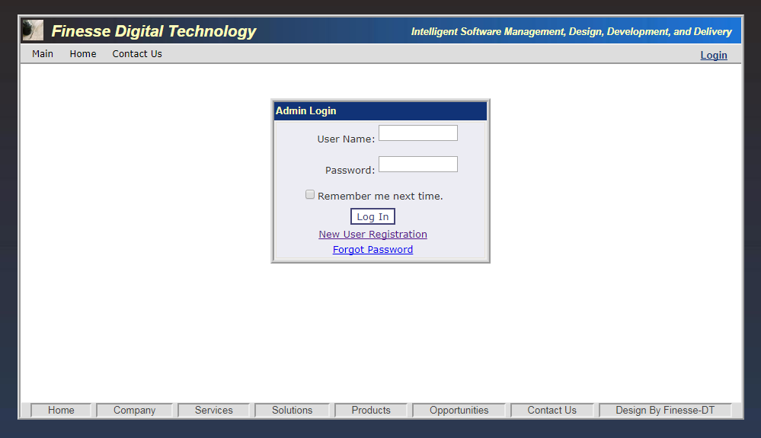

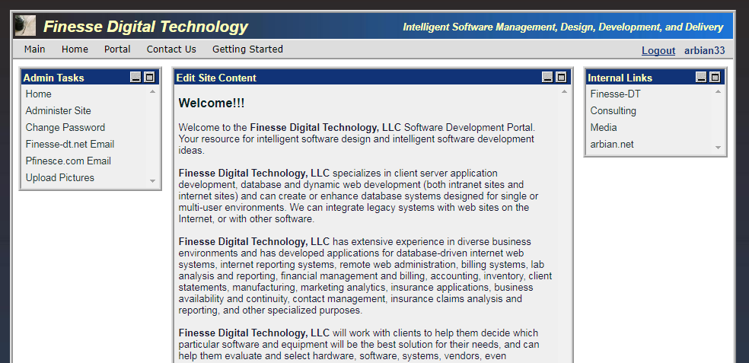

Site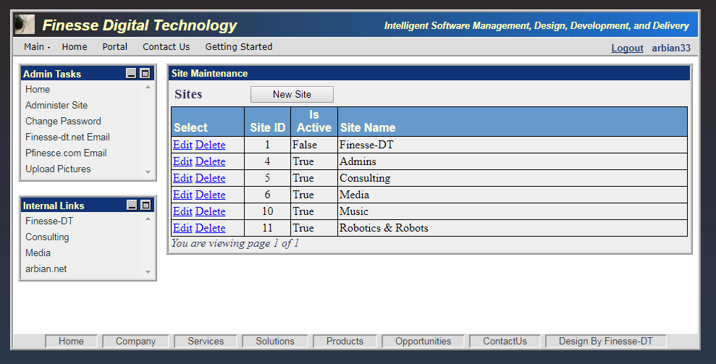

New Site

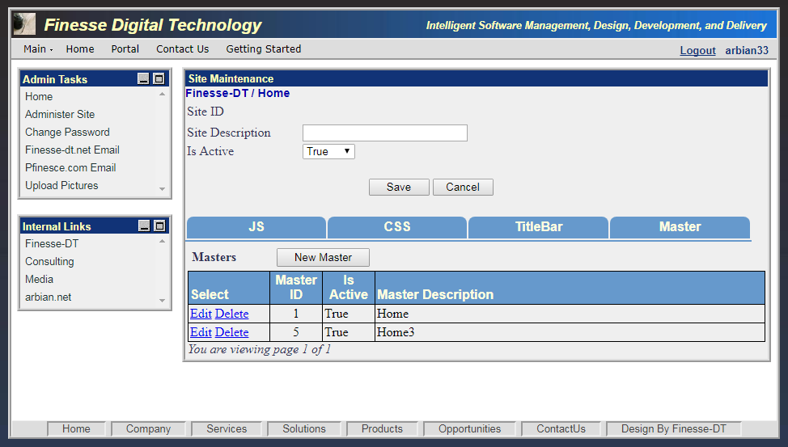

Edit Site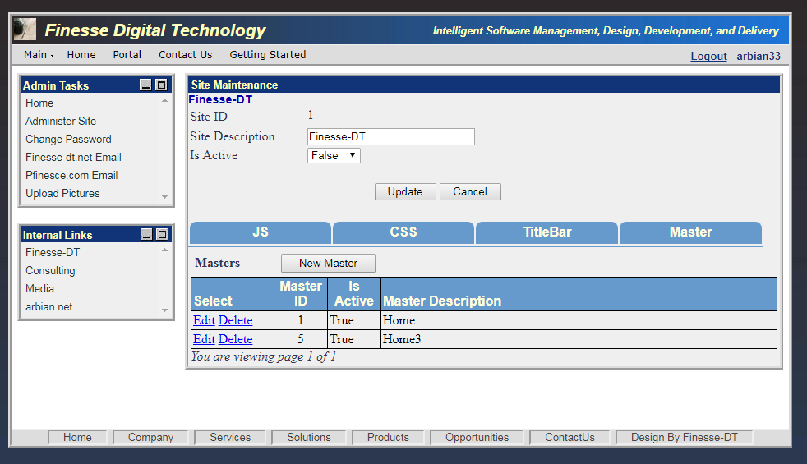

Site – Javascript Tab

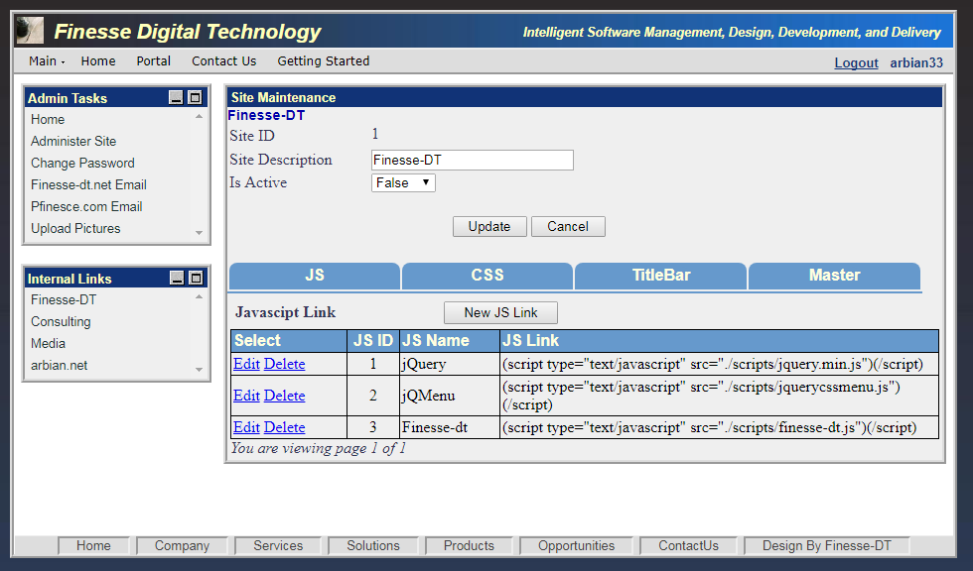

Add Javascript 